Smart Placement Management System
Branch: CSE Section: 6 Batch No: 01
Student Roll No’s :
24B11CS231
24B11CS236
24B11CS486
24B11CS148
Student Name’s :
K Tanay Kumar
S Krishna Bharadwaj
V Ganesh Reddy
G Surya Dileep
Faculty Name :
Mrs R Padma Sri

Introduction
The Smart Placement Management System (SPMS) is a full-stack web application developed to streamline and modernize the campus placement process. The system connects students, recruiters, and administrators on a single digital platform to manage job postings, applications, resume evaluation, and interview preparation.
Traditional placement processes often involve manual coordination, spreadsheet tracking, and limited communication between stakeholders. This project eliminates inefficiencies by providing a centralized, automated, and role-based placement ecosystem.
The system is developed using modern MERN stack technologies:
Frontend: React JS (Vite Setup)
Backend: Node JS with Express JS
Database: MongoDB (NoSQL)
Authentication: JWT-based Role Authentication
This application follows a separate frontend and backend architecture with MongoDB Atlas as the cloud database.
Problem Statement
In traditional placement management systems:
>Student data is managed manually or via spreadsheets
>Recruiters lack a centralized student database
>Resume screening is not automated
>Skill-based job matching is inefficient
>Application tracking is unclear
>There is no structured interview preparation support
>Hence, a smart, role-based web platform is required to automate:
>Student profile management
>Job posting and management
>Resume upload and ATS scoring
>Skill-based job recommendation
>Application tracking
>Interview preparation
Objectives of the Project
The main objectives of this project are:
>To provide secure role-based authentication (Student / Recruiter / Admin)
>To enable structured student profile and academic management
>To implement job posting and management system
>To develop a compatibility-based job recommendation engine
>To integrate ATS-based resume scoring
>To support dynamic interview preparation module
>To store semi-structured data using MongoDB
>To design a scalable full-stack architecture
Scope of the Project
The system can be used in:
>Engineering colleges
>Universities
>Placement training institutes
>Academic demonstration of MERN Stack
The application supports:
>Students for profile building, job applications, and interview preparation
>Recruiters for job posting and applicant tracking
>Admin for system-level supervision
The system is currently developed as an academic demonstration but is scalable for real-world deployment.
Modules Description

1. Authentication Module
Student Registration & Login
Recruiter Registration & Login
Admin Registration & Login
JWT Token Generation
Role-Based Access Control
Protected Routes

2. Student Module
Dashboard
Profile View & Edit
Academic Details Management
Skills Management
Social Links Integration (GitHub, LinkedIn)
Resume Upload (PDF only)
ATS Score Calculation
Interview Preparation Module
Application Tracking

3. Recruiter Module
Job Posting
Job Management
View Applicants
Application Review (Expandable)

4. Application Module
Apply to Job
Compatibility Score Calculation
Application Status Tracking
Database Persistence

5. Resume & ATS Module
Resume Upload using Multer
Resume Path Storage in Database
ATS Score based on:
Skills Matching
GitHub Presence
LinkedIn Presence
CGPA
Improvement Suggestions

6. Admin Module
Role-Based User Control
System-Level Access
Expandable Job & User Management
Database Design (MongoDB)
The system uses MongoDB, a NoSQL database that stores semi-structured JSON-like documents instead of relational tables.
The system uses MongoDB, a NoSQL database that stores semi-structured JSON-like documents.

Advantages of MongoDB in this Project
Flexible schema for different user roles
Easy storage of nested arrays (skills, applications)
Faster development with MERN stack
Cloud scalability using MongoDB Atlas
Collections Used

1. Users Collection
_id
name
email
password (hashed using Bcrypt)
role (student / recruiter / admin)
mobile
cgpa
backlogs
tenthMarks
interMarks
btechMarks
skills [Array]
github
linkedin
resumePath
createdAt
updatedAt

2. Jobs Collection
_id
title
company
description
skillsRequired [Array]
salary
location
postedBy (Recruiter ID)
createdAt

3. Applications Collection
_id
student (User ObjectId reference)
job (Job ObjectId reference)
status (Applied / Shortlisted / Rejected)
compatibilityScore
createdAt

Relationships
One Student → Many Applications
One Job → Many Applications
One Recruiter → Many Jobs
Applications reference student and job using ObjectID
System Execution Process

Folder Structure
AMSD PROJECT
│
├── client
│ ├── src
│ │ ├── pages
│ │ ├── App.jsx
│ │ └── main.jsx
│
├── server
│ ├── models
│ ├── routes
│ ├── middleware
│ ├── uploads
│ └── server.js
User Interface Design
Screens Included:
Student Login & Registration Page
Recruiter Login & Registration Page
Admin Login Page
Student Dashboard
Job Listing Page
Job Details Page
Resume Upload Page
ATS Score Display Page
Interview Preparation Page
Recruiter Dashboard
Admin Dashboard
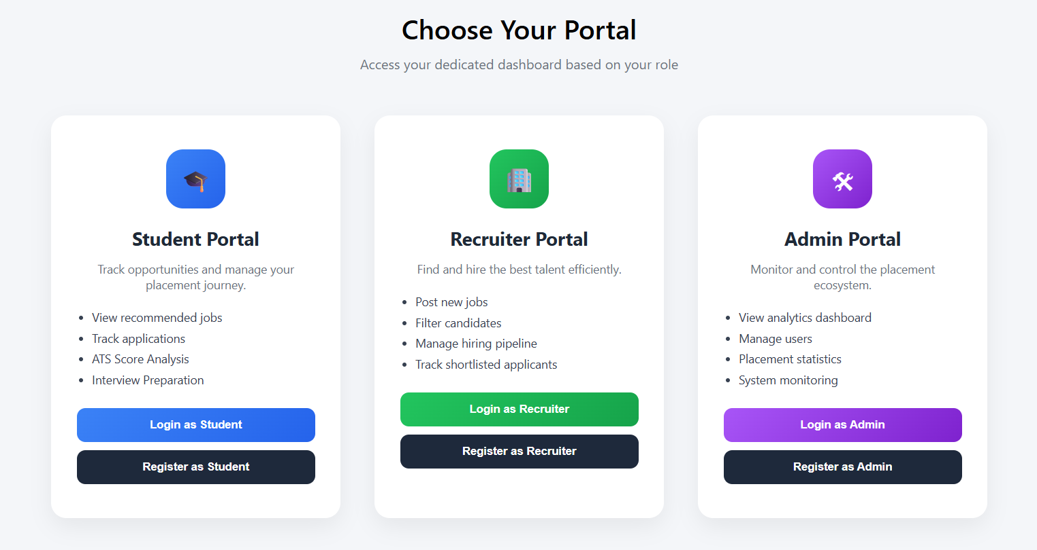
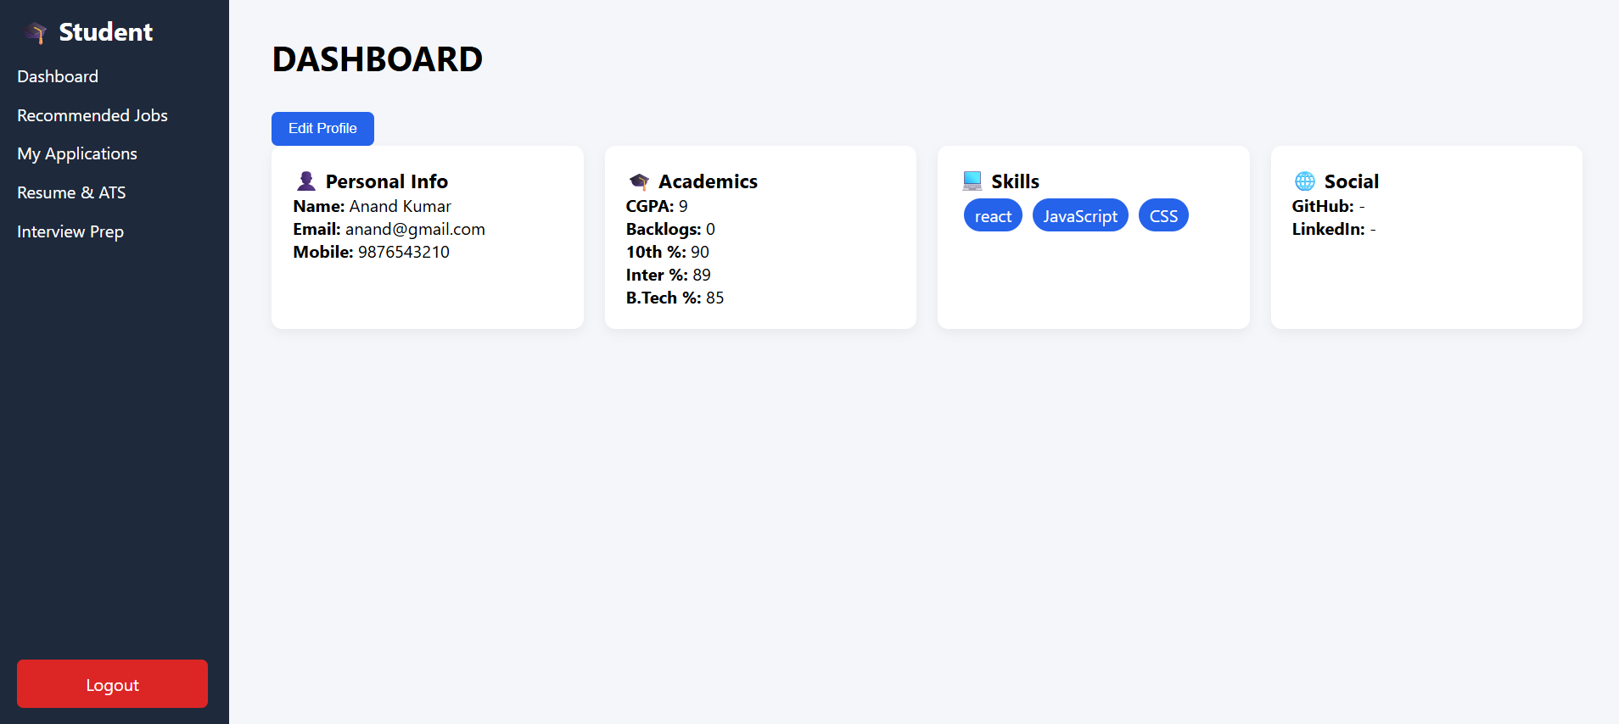
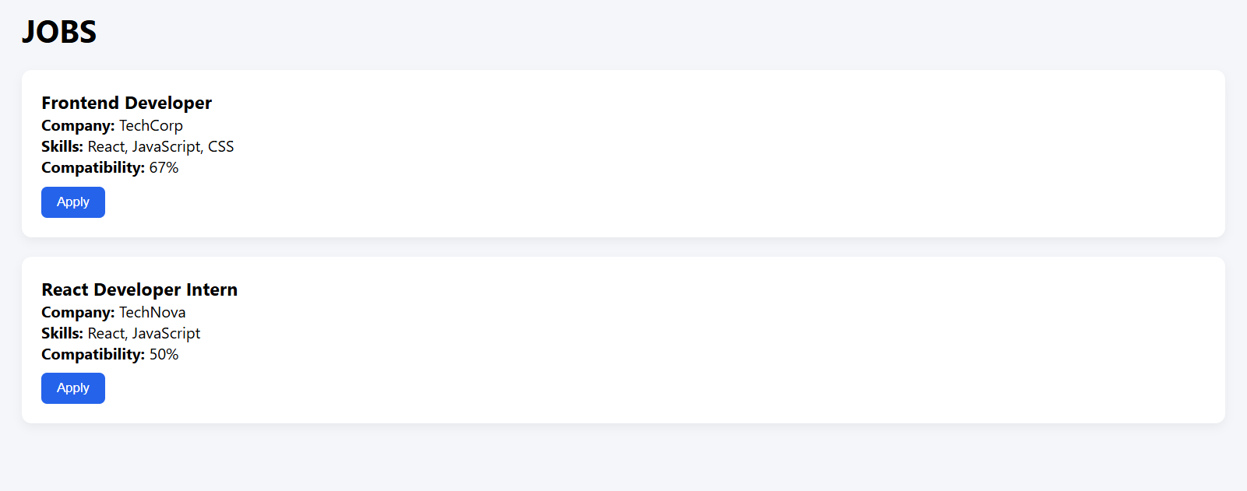
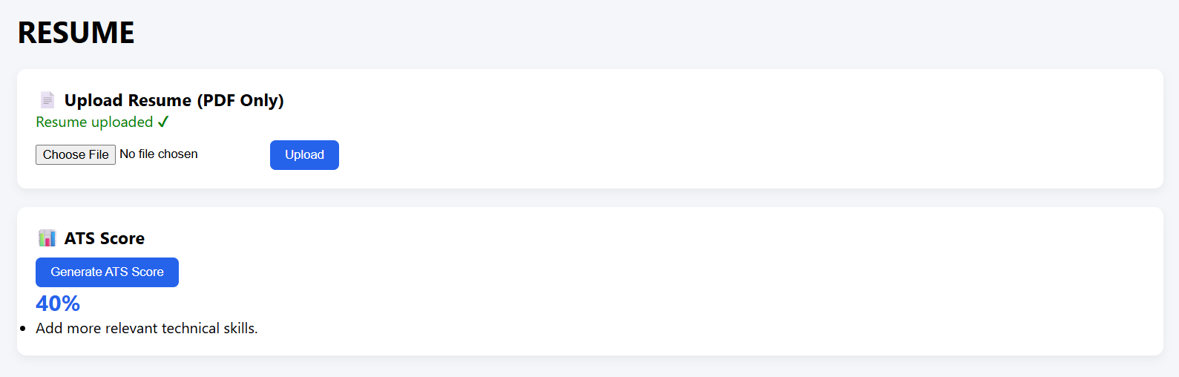
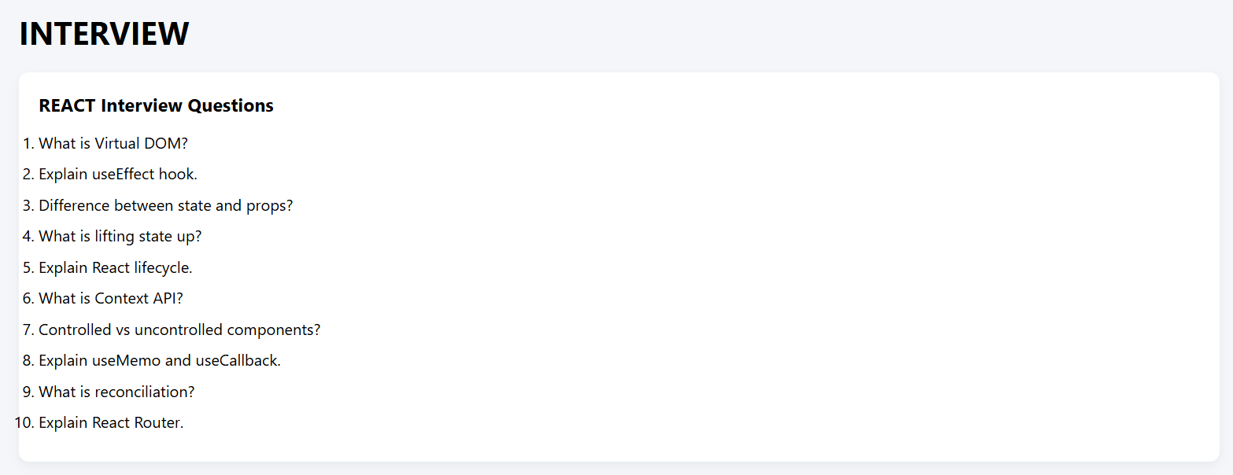
Note:
If the application is menu-based, include menu screenshots.
Conclusion
The Smart Placement Management System provides a centralized, intelligent, and scalable solution to modernize the campus placement process.
By integrating React, Node, Express, and MongoDB, the system achieves:
Secure authentication with JWT
Role-based system architecture
Automated resume scoring
Intelligent job compatibility matching
Structured application tracking
This project demonstrates a practical real-world implementation of a MERN-based role-driven placement management platform and reflects modern web development practices.

